# Implementation

1. This section discusses our project implementation, including procurement of parts and assembly.

## Component Procurement

We identified three alternatives for where to get components from.

1. Ordering from the global websites like Digikey. Advantages of this choice is availability of almost all type of components in various ratings. However, it has disadvantageous like being very expensive due to Dollar- TL currency and additional taxes and long delivery time.
2. Buying from local shops like in Konya Sokak. Advantages of that is we can get directly to components without a delivery time. Disadvantages of this choice are lack of datasheets and limited variety of components. We have used this choice as an emergency way.
3. Ordering from websites like Direnc.net or Robotistan. Advantages of that is availability of large amount of type at affordable prices and 2 or 3 days delivery time.

As a result, we get initial componenents from Direnc.net, additional compenents were supplied by local shops, specifically replacement of the bridge diode after the original one failed. We tried to find an enclosure and larger heat sinks for the diode bridge and triac locally, but we were not successful.

Table 1 lists the complete bill of materials for the project along with the procurement source and pricing. The total cost of materials for the project was approximately 95 TL.

Table 1: Bill of Material

| **Qty** | **Description** | **Unit Price** | **Ext. Price** | **Source** |
| --- | --- | --- | --- | --- |
| 1 | 4mm Protected Born Jack, Red (DC+) | 2.86 | 2.86 | Direnc.net |
| 1 | 4mm Protected Born Jack, Black (DC-) | 2.86 | 2.86 | Direnc.net |
| 1 | 4mm Protected Born Jack, Brown (AC L1) | 2.86 | 2.86 | Direnc.net |
| 1 | 4mm Protected Born Jack, Blue (AC N) | 2.86 | 2.86 | Direnc.net |
| 1 | 20mm Fuse Holder | 1.09 | 1.09 | Direnc.net |
| 5 | 5x20mm Glass Fuse | 0.15 | 0.75 | Direnc.net |
| 5 | 5x20mm Glass Fuse | 0.15 | 0.75 | Direnc.net |
| 2 | Capacitor, polyester 100nF 400V | 0.66 | 1.32 | Direnc.net |
| 2 | Resistor 1kΩ 0.125W | 0.03 | 0.06 | Team stock |
| 2 | Resistor 15kΩ 0.125W | 0.03 | 0.06 | Team stock |
| 1 | Potentiometer, 220 kΩ | 1.02 | 1.02 | Konya Sk. |
| 1 | Potentiometer, 220 kΩ | 1.02 | 1.02 | Konya Sk. |
| 2 | Potentiometer knob | 0.68 | 1.36 | Konya Sk. |
| 1 | Diode bridge, 35A 1000V | 5.80 | 5.80 | Direnc.net & Konya Sk. |
| 1 | Heat sink (diode bridge) | 9.50 | 9.50 | Local Electronic Repair Shop |
| 1 | Screw (diode bridge heat sink) | 0.50 | 0.50 | Local Electronic Repair Shop |
| 1 | Triac, 25A 600V (BTA26) | 11.59 | 11.59 | Direnc.net |
| 1 | Heat sink (triac) | 9.50 | 9.50 | Local Electronic Repair Shop |
| 1 | Screw (triac heat sink) | 0.50 | 0.50 | Local Electronic Repair Shop |
| 1 | Thermal paste |  |  | Team stock |
| 1 | Diac, 36V trigger | 0.14 | 0.14 | Direnc.net |
| 1 | Terminal Block, 3-pin | 3.57 | 3.57 | Direnc.net |
| 1 | Perfboard 12x12 | 6.82 | 6.82 | Class materials |
| 1 | Wire | 10.00 | 10.00 | Local Electrical Shop |
| 1 | Enclosure, 85x155x60mm | 18.68 | 18.68 | Direnc.net |
|  | **TOTAL** |  | **95.47** |  |

### Procurement Lessons Learned

* Even knowing the simulated voltage and current value within the limit of component, buy more than one. A wrong switching or closing can burn the most reliable component. (We had purchased duplicates of the triac and the diac, but neither of them failed. We had one diode bridge, and it failed. Murphy’s Law….)
* Online listing may not match the received material so do not choose other components without seeing visually by yourself. (In fact, we tried to find heat sinks and enclosure locally, but did not find a local source.)
* Inner dimensions of the box can be different due to parts that used in connection of box, try to buy locally where it can be “tried on” in the shop, or order a bigger box.
* Find a local shop that you can go easily in case of emergency situation like forgetting to order components or burning case.
* Order to suitable input-output terminals and implement your circuit. When you are on the implementation phase of circuit, you need to plug the input and output cable so many times and this can cause a trouble for circuit.
* Order different rating fuses, you can use low rating fuses at the start of your project.

## Project Assembly

As soon we we had procured the essential components for our project circuit, we began temporary assembly with wires twisted together and minimal soldering. After making the initial circuit connections, we start to test our circuit. According to our test result we made changes in the circuit such as changing potentiometer rating for good control at output and changing the size of heatsinks. Once we were confident that our design would work, we moved to make the connections on the perfboard neat and soldered connections.

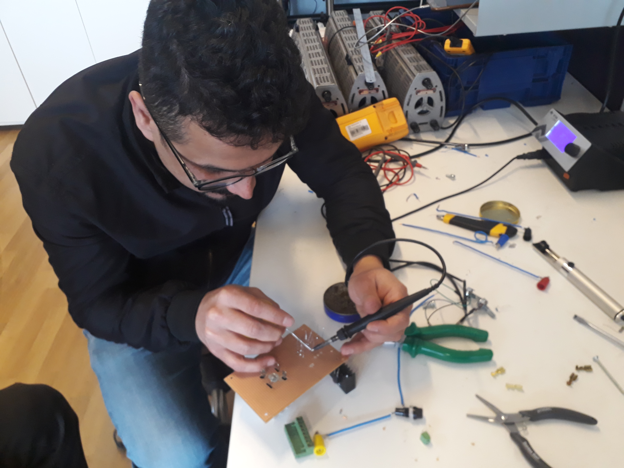 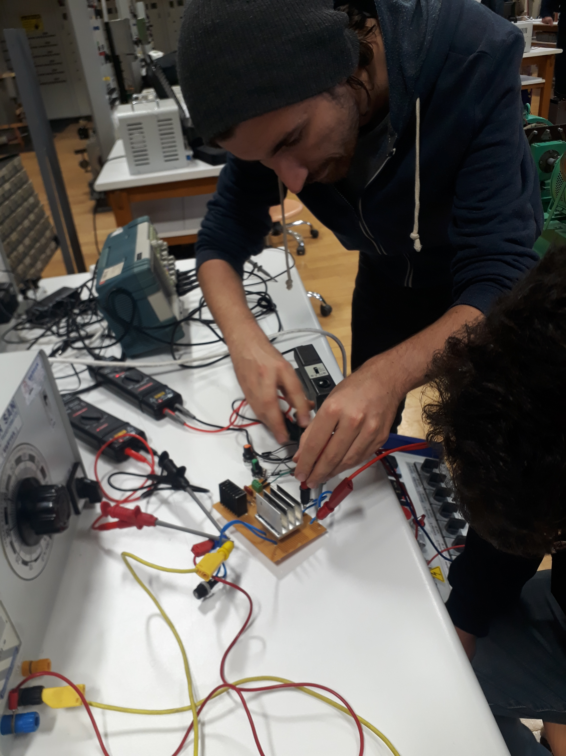

Figure 1: Photos of Project Assembly and Testing

During testing, we had observed that the triac heat sink was running hotter than we wanted at load levels that were slightly less than what we expected from the kettle load. As such, we preferred to use a larger heat sink for the triac. We were not successful in locating heat sinks and an enclosure locally, so we ordered these parts from Direnc.net.

Although the dimensions for the heat sink and enclosure as listed on the website should have been adequate, the enclosure turned out to be constructed with the connection between the upper and lower halves of the enclosure such that it majorly interfered with utilizing all the interior volume of the enclosure. We were able to modify the interior of the box, cutting out the supports that were interfering with mounting our components in the enclosure, but then the enclosure did not close securely as it was designed to do.

Additionally, the heat sink that we received was several centimeters larger than the published dimensions of the heat sink on the Direnc.net website, so it was unable to fit in the enclosure. As such, we had to stay with our first heatsinks and were not able to change them out as we had wanted to do based on our testing.

### Project Assembly Lessons Learned

* Drawing the circuit schematic *including pinouts & connections* can be logical for project. Our circuit was so simple that it seemed we could assemble it from memory, but in fact we lost time troubleshooting wrong connections that could have been prevented by more careful design documentation, particularly layout with attention to device pinouts.
* Terminals of the triac and bridge rectifier did not fit the holes in our perfboard. So, we drilled holes for those components. After that point, connection changes in these two components cause us lots of trouble. We could have bought terminal blocks (of appropriate current and voltage rating) for these components and connected them to the circuit board with the help of the terminal blocks.
* Doing minimal assembly so as to begin testing as early as possible worked well in most regards, but there were instances where we had to resolder connections due to the stresses of connecting and disconnecting from connectors that were not mounted in an enclosure as they are intended to be.